



St Peter’s C of E Primary Academy
Special Educational Needs and Disability (SEND) Policy

Date | Full  Formal  Review  Date | Head Teacher | Special Educational  Needs & Disability  Co-ordinator  (SENDCO) | Nominated Governors
November 2025 | November 2026 | Miss Ann-Marie Wilson | Mrs L Hodge | Mrs K Esmond  Ms Ami Ceclich

“The purpose of education for all children is the same; the goals are the same. But help that individual children need in progressing towards them will be different. Whereas for some, the road they travel towards the goal is smooth and easy; for others it is fraught with obstacles.” (Warnock Report, 1.4)

Mission Statement
St Peter’s C of E Primary Academy (SPA) seeks to provide a high-quality academic education for all pupils according to their individual needs, and to develop attitudes of mutual respect and responsibility. It aims to give high priority to the spiritual development of the whole school community in a Christian environment.

Introduction
At SPA, we are committed to offering an inclusive curriculum to ensure the best possible progress for all of our pupils whatever their needs or abilities. Not all pupils with disabilities have special educational needs and not all pupils with Special Educational Needs and Disability (SEND) meet the definition of disability but this policy covers all of these pupils.
Children may have special educational needs either throughout or at any time during their school career. This policy ensures that curriculum planning and assessment for children with special educational needs takes account of the type and extent of the difficulty experienced by the child.

Definitions of special educational needs (SEN) taken from section 20 of the Children and Families Act 2015.
A child or young person has SEN if they have a learning difficulty or disability, which calls for special educational provision to be made for them. A child of compulsory school age or a young person has a learning difficulty or disability if they:
- have a significantly greater difficulty in learning than the majority of others of the same age; or
- have a disability which prevents or hinders them from making use of educational facilities of a kind generally provided for others of the same age in mainstream schools or mainstream post-16 institutions.
A child under compulsory school age has special educational needs if they fall within the definition at (a) or (b) above or would do so if special educational provision was not made for them.
Children must not be regarded as having a learning difficulty solely because the language or form of language of their home is different from the language in which they will be taught.

There are four distinct categories of SEND need as identified within the Code of Practice 2014:

- Communication and Interaction
Children and young people may have difficulties in one or more areas of speech, language and communication. They may also include Dyslexia or a physical or sensory impairment such as hearing loss.

- Cognition and Learning
Children and young people with learning difficulties will learn at a slower pace and may have greater difficulties than their peers in acquiring basic literacy and numeracy skills or in understanding concepts even with a level of appropriate intervention. They may also have difficulties such as speech and language delay, low self-esteem, low levels of concentration and under-developed social skills

- Social, emotional and mental health difficulties
For some children difficulties in emotional and social development can mean that they require additional or different provision in order for them to achieve. Children who have difficulties with their emotional and social development may have immature social skills and find it difficult to make or sustain healthy relationships. These difficulties may be displayed through the child or young person becoming withdrawn or isolated as well as through challenging disruptive or disturbing behaviours

- Sensory and/or physical
There are a wide range of sensory or physical difficulties that may affect children within the school. These may require minor adaptations to the curriculum or the physical environment. These adaptations may be seen as reasonable adjustments under the Equality Act 2010. These sensory impairments may be visual impairments (VI) or hearing impairments (HI)

We have children in all of these categories of SEND.

The SEND Local Offer (https://sendlocaloffer.nelincs.gov.uk/) is a resource, which is designed to support children and young people with special educational needs and/or disabilities and their families. It describes the services and provision that are available both to those families in North East Lincolnshire that have an Education, Health and Care Plan and those who do not have a plan but still experience some form of special educational need. The SEND Local Offer includes information about public services across education, health and social care, as well as those provided by the private, voluntary and community sectors. See the school’s website for a copy of our SEND Information Report which details the school’s SEND offer.
Aims and Objectives

Aims

We aim to provide every child with access to a broad and balanced education. This includes the National Curriculum in line with the Special Educational Needs Code of Practice.
Our aims are:
- To provide curriculum access for all.
- To secure high levels of achievement for all.
- To meet individual needs through a wide range of provision.
- To attain high levels of satisfaction and participation from pupils, parents and carers.
- To ensure a high level of staff expertise to meet pupil need, through well targeted continuing professional development.
- To work in cooperative and productive partnership with the Local Authority and other outside agencies, to ensure there is a multi-professional approach to meeting the needs of all vulnerable learners.

Objectives
- Identify the needs of pupils with SEND as early as possible. This is most effectively done by gathering information from parents, education, health and care services and Early Years settings prior to the child’s entry into the school.
- Monitor the progress of all pupils in order to aid the identification of pupils with SEND.
- Continuous monitoring of those pupils with SEND by their teachers will help to ensure that they are able to reach their full potential.
- Make appropriate provision to overcome all barriers to learning and ensure pupils with
SEND have access to the National Curriculum. This will be coordinated by the Special Educational Needs and Disability Coordinator (SENDCO) and will be carefully monitored and regularly reviewed in order to ensure that individual targets are being met and all pupils’ needs are catered for.
- We work with parents to gain a better understanding of their child and involve them in all stages of their child’s education. SPA is committed to working in partnership with parents, children, and other members of the school community to provide for the needs of every child. The school recognises that parents have valuable knowledge and experience that will contribute to the shared view of their child’s needs. All parents of children with special educational needs will be treated as partners and supported to play an active and valued role in their children’s education.
- Work with and in support of outside agencies when the pupils’ needs cannot be met by the school alone. SPA works in partnership with professionals from Health, Social or Educational Services in assisting and planning future support. Voluntary Organisations may be consulted as appropriate.
- Create a school environment where pupils feel safe to voice their opinions of their own needs. Pupil participation is a right. This will be reflected in decision-making but also encouraged through wider opportunities for participation in school life membership of the School Council. Children and young people with special educational needs have knowledge of their own needs and what may help them in their Learning. They will be encouraged to participate in and contribute to the assessment of their needs, the review and transition processes. Alongside this, pupil voice will also be collected through SEND monitoring.
- All educational visits will be planned with current DfE and national guidance in mind. Each trip will be given thoughtful consideration to ensure that pupils with SEN and physical disabilities are not discriminated against. Similarly, the extra-curricular offer from school ensures all are welcome, regardless of individual needs.
- For social, emotional and mental health concerns, our Pastoral Team work with children on an individual and group basis. All children are considered in terms of their individual needs. In this way children are provided either with specific support or within small group support and where necessary, referred to outside agencies for more specific/specialist support to support their wellbeing.

Admission Arrangements
The admission arrangements for all pupils are in accordance with national legislation, including the Equality Act 2010. This includes children with any level of SEND; those with Education, Health and Care Plans and those without.

SPA recognises that each child will have unique needs and welcomes all children irrespective of their need. We will endeavour to provide a quality educational experience, which is effective in meeting their specific needs. This would be agreed upon in consultation with parents and outside agencies. These may require physical adaptations to the school, specialised teaching skills and equipment. Staff development, external support and specific resourcing may also be required to ensure that each child receives the educational experience to which they are entitled.

All of our classrooms are inclusion-friendly: we aim to teach in a way that will support children with tendencies towards or a diagnosis of dyslexia, dyspraxia, Autism Spectrum Disorder (ASD) etc. It is good practice to support all children but is vital for those who particularly need additional support. Our children access the full National Curriculum, and we recognise and celebrate achievement and expertise in all curricular areas. As part of normal classroom practice, curriculum content and ideas can be adapted, simplified and/or made more accessible by using visual, tactile and concrete resources to suit individual learning styles.

Roles and Responsibilities

Headteacher
- The Head Teacher is responsible for monitoring and evaluating the progress of all pupils and for making strategic decisions which will maximise their opportunity to learn
- The Head Teacher and the Local Council will delegate the day-to-day implementation of this policy to the SENCO
- The Head Teacher will be informed of the progress of all vulnerable learners and any issues with regard to the school’s provision in this regard through:
- Analysis of the whole-school pupil progress tracking system;
- Maintenance and analysis of a whole-school provision map for vulnerable learners;
- Pupil progress meetings;
- Regular meetings with the SENCo;
- Discussions and consultations with pupils and parents.

Special Educational Needs Coordinator (SENCo)

In line with the SEN Code of Practice 2015, the SENCo will oversee the day-to-day operation of this policy in the following ways:
- Maintenance and analysis of whole-school provision map for vulnerable learners;
- Co-ordinating provision for children with Special Educational Needs;
- Liaising with and advising teachers;
- Managing other classroom staff involved in supporting vulnerable learners;
- Overseeing the records on all children with Special Educational Needs and/or a disability;
- Contributing to the in-service training of staff and ensure ongoing continuing professional development opportunities for staff development;
- Completing Annual Reviews for all pupils with an EHCP;
- Requesting EHC needs assessments when a Graduated Approach has been exhausted and a pupil may have significant Special Educational Needs which will require support above and beyond that which can be provided through delegated funding;
- Overseeing the running of transition arrangements and transfer of information for pupils with SEND who transfer from one phase of education to another;
- Monitoring the school’s system for ensuring that Individual Support Plans, where it is agreed they will be useful for a pupil with Special Educational Needs, have a high profile in the classroom and with pupils;

- Evaluating regularly the impact and effectiveness of all additional interventions for all vulnerable learners (including those with Special Educational Needs);
- Meeting regularly with each teacher to review and revise learning objectives for all vulnerable learners in their class who are on the SEND Register;
- Liaising and consulting sensitively with parents and families of pupils on the SEN register, keeping them informed of progress and listening to their views of progress, in conjunction with class teachers and outside agencies;
- Attending area SENCo cluster meetings and training as appropriate;
- Liaising with the school’s SEN Governor, keeping them informed of current issues regarding
provision for vulnerable learners, including those with SEND (nationally, locally and within school);
- Liaising closely with a range of outside agencies to support vulnerable learners;
- Ensuring effective deployment of resources – including teaching assistant support - to maximise outcomes for all groups of vulnerable learners.

Class Teachers

Each class teacher and key worker is responsible for:
- The progress and development of every pupil in their class;
- Providing high quality teaching for all pupils and additional provision to meet the needs of children with SEND;
- Working closely with any teaching assistants or specialist staff to plan and assess the impact of support and interventions and how they can be linked to classroom teaching;
- Working with the SENCo to review each pupil’s progress and development and decide on any changes to provision;
- Ensuring they follow this SEND policy.

SEND Governance

To meet the statutory requirements of the Code of Practice (2015)
- There must be a member of the Academy Committee with specific oversight of the school’s
arrangements for SEN and disability.
- The Local council of an Academy must publish information on their websites about the implementation of the Academy Committees policy for pupils with SEN. The information published should be updated annually and any changes to the information occurring during the year should be updated as soon as possible.
The information required is set out in the Special Educational Needs and Disability Regulations 2014 and
must include information about:
- The kinds of SEND that are provided for in school and the approach to teaching;
- Arrangements for consulting parents of children and young people with SEN and involving them in their child’s education;
- Policies for identifying children and young people with SEN and assessing their needs;
- Arrangements for assessing and reviewing children and young people’s progress towards outcomes. This should include the opportunities available to work with parents and young people as part of this assessment and review;
- Arrangements for supporting children and young people in moving between phases of education and preparing for adulthood;
- How adaptations are made to the curriculum and the learning environment of children and young people with SEN;

- The expertise and training of staff to support children and young people with SEN, including how specialist expertise will be secured;
- Evaluating the effectiveness of the provision made for children and young people with SEN;
- How children and young people with SEN are enabled to engage in activities available with children and young people in the school who do not have SEN;
- Support for improving emotional and social development. This should include pastoral support arrangements for listening to the views of children and young people with SEN and measures to prevent bullying;
- How the school involves other bodies, including health and social care bodies, local authority support services and voluntary sector organisations, in meeting children and young people’s SEN and supporting their families;
- Arrangements for handling complaints from parents of children with SEN about provision at school.

SEND Procedure and Practice
The school is committed to early identification of special educational need and adopts a graduated approach to meeting special educational need in line with the Code of Practice (2015). (See Appendix 1)

Quality First Teaching
Any pupils who are falling significantly outside the range of expected academic achievement in line with predicted performance indicators and grade boundaries will be monitored.

Identification Methods used at SPA:
- Early Years Inclusion Support Service or other agencies may inform the school about a forthcoming admission of a child with SEND.
- Foundation Stage entry profile assessment.
- During a child’s school career parents or a class teacher may raise a concern.
- Pupil progress and SEND meetings with the Head teacher and Class Teacher, may raise a concern about a child’s progress.
- Regular progress and target setting meetings between class teachers, the intervention teachers and HLTA’s may highlight any concerns regarding progress and understanding.
- The child’s class teacher may assess their needs and, in consultation with parents, identify the level of support they are likely to require.
- More formal assessments may be completed if needed with the SENDCO.
- Once a pupil has been identified as possibly having SEND they will be closely monitored by staff in order to gauge their level of learning and possible difficulties, taking a holistic view of the child.
- The child’s class teacher will take steps to provide adapted learning opportunities and reasonable adjustments that will aid the pupil’s academic progression and enable the teacher to better understand the provision and teaching style that needs to be applied.
- The SENDCO will be consulted as needed for support and advice and may wish to observe the pupil in class.
- Through (b) and (d) it can be determined which level of provision the child will need in order to address their needs and move forward.
- If a pupil has recently been removed from the SEND register, they will continue to be monitored to ensure they continue to make progress.
- Parents will be informed fully of every stage of their child’s development and the circumstances under which they are being monitored. They are encouraged to share information and knowledge with the school. Parents will be invited into school for a review each term to discuss their child’s progress.

- The child is formally recorded by the school as being under observation due to concern by parent or teacher but this does not place the child on the school’s SEND register. Parents are given this information. It is recorded by the school as an aid to further progression and for future reference.
- Pupil progress meetings are used to monitor and assess the progress being made by the child.
- The SENDCO will monitor and track progress of all SEND pupils on a termly basis using a small steps approach.

SEND Support
Where it is determined that a pupil does have SEND, parents will be formally advised of this and the decision will be added to the pupil’s record. The aim of formally identifying a pupil with SEND is to help school ensure that effective provision is put in place and so remove barriers to learning. The support provided consists of a four – part process:
- Assess
- Plan
- Do
- Review

This is an ongoing cycle to enable the provision to be refined and revised as the understanding of the needs of the pupil grows. This cycle enables the identification of which interventions are the most effective in supporting the pupil to achieve good progress and outcomes.

Assess
This involves clearly analysing the pupil’s needs using the class teacher’s assessment and experience of working with the pupil, details of previous progress and attainment, comparisons with peers and national data, as well as the views and experience of parents. The pupil’s views and where relevant, advice from external support services will also be considered. Any parental concerns will be noted and compared with the school’s information and assessment data on how the pupil is progressing.

This analysis will require regular review to ensure that support and intervention is matched to need, that barriers to learning are clearly identified and being overcome and that the interventions being used are developing and evolving as required. Where external support staff are already involved their work will help inform the assessment of need. Where they are not involved they may be contacted, if this is felt to be appropriate, following discussion and agreement from parents.

Plan
Planning will involve consultation between the teacher, SENDCO and parents to agree the adjustments, interventions and support that are required; the impact on progress, development and/or behaviour that is expected and a clear date for review. Parental involvement may be sought, where appropriate, to reinforce or contribute to progress at home. All those working with the pupil, including support staff will be informed of their individual needs, the support that is being provided, any teaching strategies/approaches that are being employed and the outcomes that are being sought.

Do
The class teacher remains responsible for working with the child on a day-to-day basis. They will retain responsibility even where the interventions may involve group or one-to one teaching
away from the main class teacher. They will work closely with teaching assistants and /or relevant specialist staff to plan and assess the impact of support and interventions and links with classroom teaching. Support with further assessment of the pupil’s strengths and weaknesses, problem solving and advising of the implementation of effective support will be provided by the SENDCO.

Review
Reviews will be undertaken in line with agreed dates. The review process will evaluate the impact and quality of the support and interventions. It will also take account of the views of the pupil and their parents. The class teacher will revise the support and outcomes based on the pupil’s progress and development, making any necessary amendments going forward, in consultation with parents and the pupil.

Parents will be provided with clear information about the impact of support to enable them to be involved in planning the next steps.

Referral For An Education, Health And Care Plan
If a child has lifelong or significant difficulties they may undergo a Statutory Assessment Process, which is usually requested by the school but can be requested by a parent. This will occur where the complexity of need or a lack of clarity around the needs of the child are such that a multi-agency approach to assessing that need, to planning provision and identifying resources, is required. The decision to make a referral for a statement will be taken at a progress review.

The application for an Education, Health and Care Plans (EHC Plan) will combine information from a variety of sources including:
- Special Educational Needs Policy 2015
- Parents
- Other Professionals
- SENDCO
- Social Care
- Health professionals

Information will be gathered relating to the current provision provided, action points that have been taken, and the preliminary outcomes of targets set. The aforementioned information will be recorded on ‘My Plan’ for each individual pupil. A decision will be made by a group of people involved: from education, health and social care about whether the child is eligible for an EHC Plan. Parents have the right to appeal against a decision not to initiate a statutory assessment leading to an EHC Plan.

The parents of any child who is referred for statutory assessment will be kept fully informed of the progress of the referral. Children with a statement of special educational needs or EHC Plan will be reviewed each half term in addition to the statutory annual assessment. When this coincides with transfer to secondary school, the SENDCO from the secondary school will be invited to and informed of the outcome of the review.

Working In Partnerships With Parents
SPA believes that a close working relationship with parents is vital in order to ensure:
- early and accurate identification and assessment of SEND leading to the correct intervention and provision.
- continuing social and academic progress of children with SEND.
- personal and academic targets are set and met effectively.

SPA is committed to working in partnership with parents, children, and other members of the school community as well as outside agencies to provide for the needs of every child. The school recognises that parents have knowledge and experience that will contribute to the shared view of a child’s needs. All parents of children with special educational needs will be treated as partners and supported to play an active and valued role in their children’s education.

Information on support agencies, including the Special Educational Needs and Disabilities Information, Advice, and Support Service (SENDIASS), is available from the SENDCO.

We can always be contacted for an appointment to discuss other concerns. Parents can contact their class teacher at the beginning or the end of the day to make an appointment or by phoning or emailing the school office.

The SENDCO: Mrs L Hodge can be contacted by phoning the school office 01472 691964 or by email: louise.law@stpeters.laat.co.uk

Parents are kept up to date with their child’s progress through parent’s evenings, IEP meetings, review meetings and reports throughout the year, including the child to gain their views and make decisions about the support they receive. In cases where more frequent regular contact with parents is necessary, this will be arranged based on the individual pupil’s needs. The SENDCO may also signpost parents of pupils with SEND to the local authority Special Educational Needs and Disabilities Information, Advice, and Support Service (SENDIASS) where specific advice, guidance and support may be required.

If an assessment or referral indicates that a pupil has additional learning needs the parents and the pupil will always be consulted with regards to future provision. Parents are invited to attend meetings with external agencies regarding their child, and are kept up to date and consulted on any points of action drawn up in regards to the provision for their child.

The school’s SEND governor may also be contacted at any time in relation to SEND matters, via the school office.

Links with Other Agencies and Voluntary Organisations
SPA invites and seeks advice and support from external agencies in the identification and assessment of, and provision for, SEND. The SENDCO is the designated person responsible for liaising with the following:
- Specialist Teaching Service
- Early Years Team
- Education Psychology Service (EP)
- NAVIGO neurodevelopmental services (ASD and ADHD)
- Young Minds Matter (formally CAMHS)
- Social Services
- Speech and Language Service
- Occupational Therapists
- Physiotherapists

Representatives from voluntary organisations and other external agencies are invited to liaison meetings throughout the year to discuss SEND provision and progress and keep staff up to date with legislation.

Transition Arrangements

Transition into and within school
We understand how difficult it is for children and parents as they move into a new class or a new school and will do what we can, according to the individual needs of the child, to make transitions between classes - including from the nursery - as smooth as possible. This may include, for example:
- Additional meetings for the parents and child with the new teacher
- Meeting, on the first morning, with Pastoral Teaching Assistant to discuss our behaviour and reward systems, our expectations and any other concerns/issues that the child may have.
- Additional visits to the classroom environment in order to identify where the toilets are, where the pegs are etc.
- Opportunities to obtain photographs of key people and places in order to make a transition booklet.
- Enhanced transition arrangements are tailored to meet individual needs.
- Home visits are conducted for those children starting in EYFS.

Transition to Secondary School
Transition reviews for Year 6 pupils, who have EHC Plans, are held, where possible, in the Autumn term of Year 6. The secondary school SENDCO is invited to Annual Reviews and attend other review meetings, where possible. Additional transition arrangements may be made at these reviews e.g. extra visits, travel training etc.

During the Spring/early Summer term the Year 6 teacher and the SENDCO
meet with staff from the secondary feeder schools to discuss the pupils making the transition into Year 7. Information exchanged during these meetings includes:
- Siblings
- Friendship groups
- Interests
- Strengths
- Any musical instruments played
- SEND
- If a pupil would benefit from additional visits to the school

During July, School SENDCO, liaises with each secondary school to communicate with the SENDCO &/or school nurse in order to discuss our SEND pupils. We try to ensure that the new school has an in-depth knowledge and understanding of the child and their individual needs, share their current data, relevant information and to personally hand over the pupil file.

Raising Awareness of this Policy

We will raise awareness of this policy via:
- the school website
- meetings with parents such as introductory, transition, parent-teacher consultations and periodic curriculum workshops
- school events
- meetings with school personnel
- communications with home such as newsletters
- reports such as the annual report to parents and Head Teacher reports to the Governing Body
- information displays in the main school entrance.

Equality Impact Assessment

As a school community, we have a commitment to promote equality. Therefore, an equality impact assessment has been undertaken and we believe this policy is in line with the Equality Act 2010.

Under the Equality Act 2010 we have a duty not to discriminate against people on the basis of their age, disability, gender, gender identity, pregnancy or maternity, race, religion or belief and sexual orientation.

This policy has been equality impact assessed and we believe that it is in line with the Equality Act 2010 as it is fair, it does not prioritise or disadvantage any pupil and it helps to promote equality at this school.

Assessment on Entry and in-school transition

Any child who joins the school will have an initial assessment.
When a child joins EYFS (Reception Class) – this process starts as soon as the school has confirmation that the parents have accepted the place. The school SENDCO and / or the EYFS team will:
- Meet every parent / carer (either at an open day or by special arrangement) to talk about the child and gather information, give out survey / questionnaire about what the child can / cannot do, speak with any nursery provision and any already involved outside agencies – to build a profile of each child. In addition, during taster days’ children and parents will be given the opportunity to add to this information base.

Any child who joins the school into another year group will have an assessment (might be very informal) based on information from family and the transferring school. If the records or family indicate SEN, then the SENCO will arrange a meeting with family and contact previous school for more information.

In-school transition:
- Particular care will be taken with the FS2 to Y1 transfer and staff will work with the SENCO to arrange an appropriate handover of information for any children with SEN.
- Transition from KS1 to KS2 will be the responsibility of the Head of School and the SENCO.

Monitoring the Effectiveness of the Policy

A review of the SEND policy document is undertaken every year. The SEND policy is a working document and is kept under constant review. A paper copy can be provided upon request.

Date last reviewed: July 2025

Next review date: July 2026

Useful website for parents of children who experience SEND:
- http://www.nhs.uk/Livewell/Childrenwithalearningdisability/Pages/Education.aspx
- https://www.gov.uk/government/uploads/system/uploads/attachment_data/file/41 7435/Special_educational_needs_and_disabilites_guide_for_parents_and_carers.p df
- NELC SEND Local Offer | North East Lincolnshire Special Educational Needs & Disability (nelincs.gov.uk)

Appendix 1

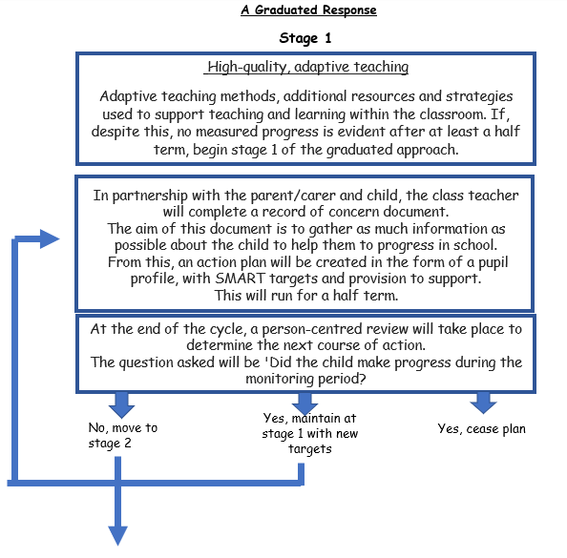

Appendix 1

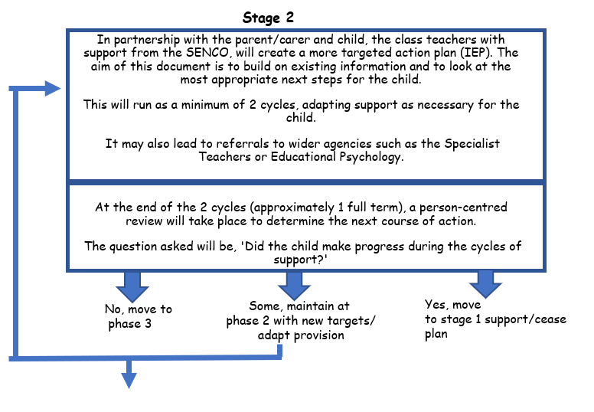

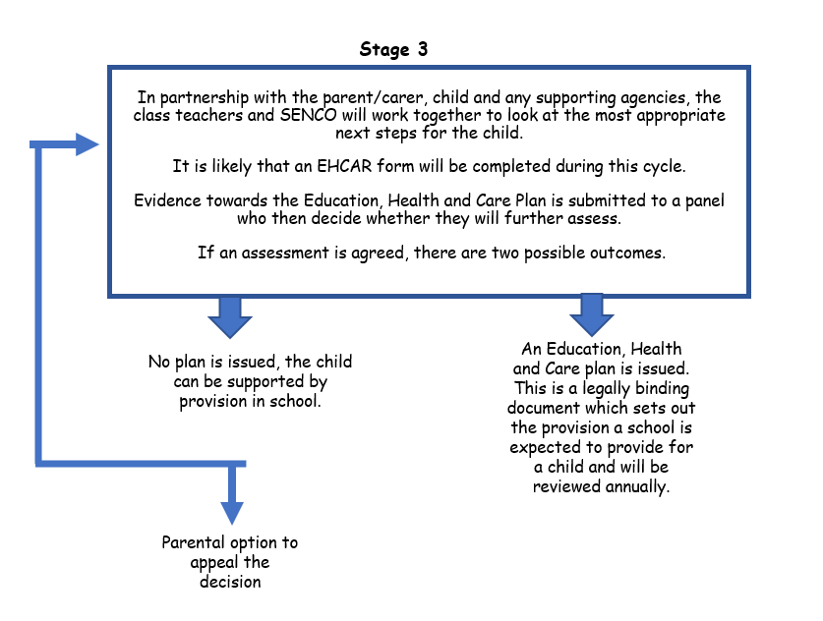
Appendix 1

